Jordan Alexis Bramson ORT Collage
1/18/2016
Game Class:
The Unfair Game.

Hello again it seems that you are playing another one of my “impossible” games. Now this one is just a little bit tougher than the last one. This one has some one from the last one and also an invisible hurt maze. How unfortunate huh. Well unlike my last one this one has to heal zones and I not telling you where you will figure it out any way so why not right. I mean you must be asking that I'm as sadistic little prick right? Well you might be right but you might want to hate to people who gave me the idea for these games of mine. The people I'm talking about is those who made Cat Mario, I Wanna Be The Guy, Super Mario Maker: Ross's levels, and The Impossible Maze.

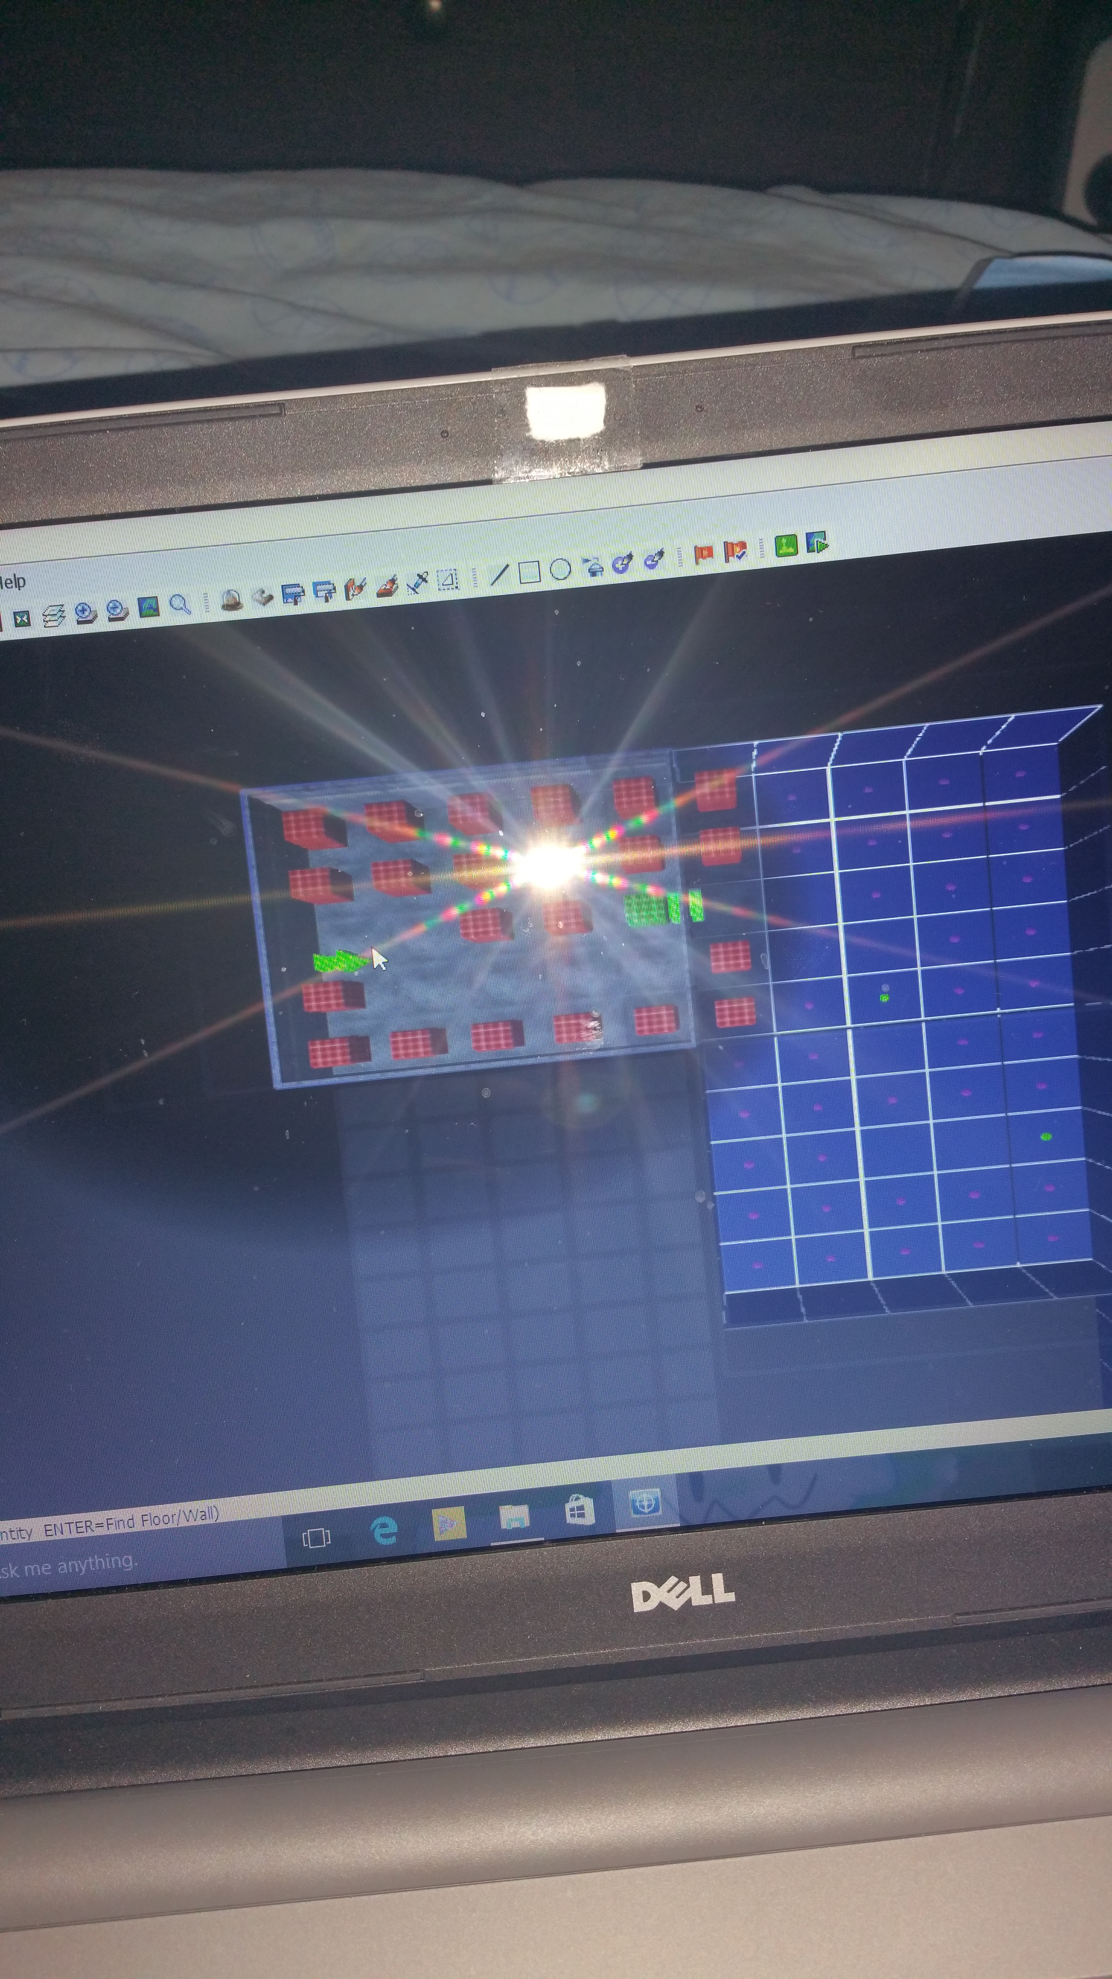
The place you start out in. Seeing as is it looks pretty bad already but looks like there is a heal zone at the end so hooray.

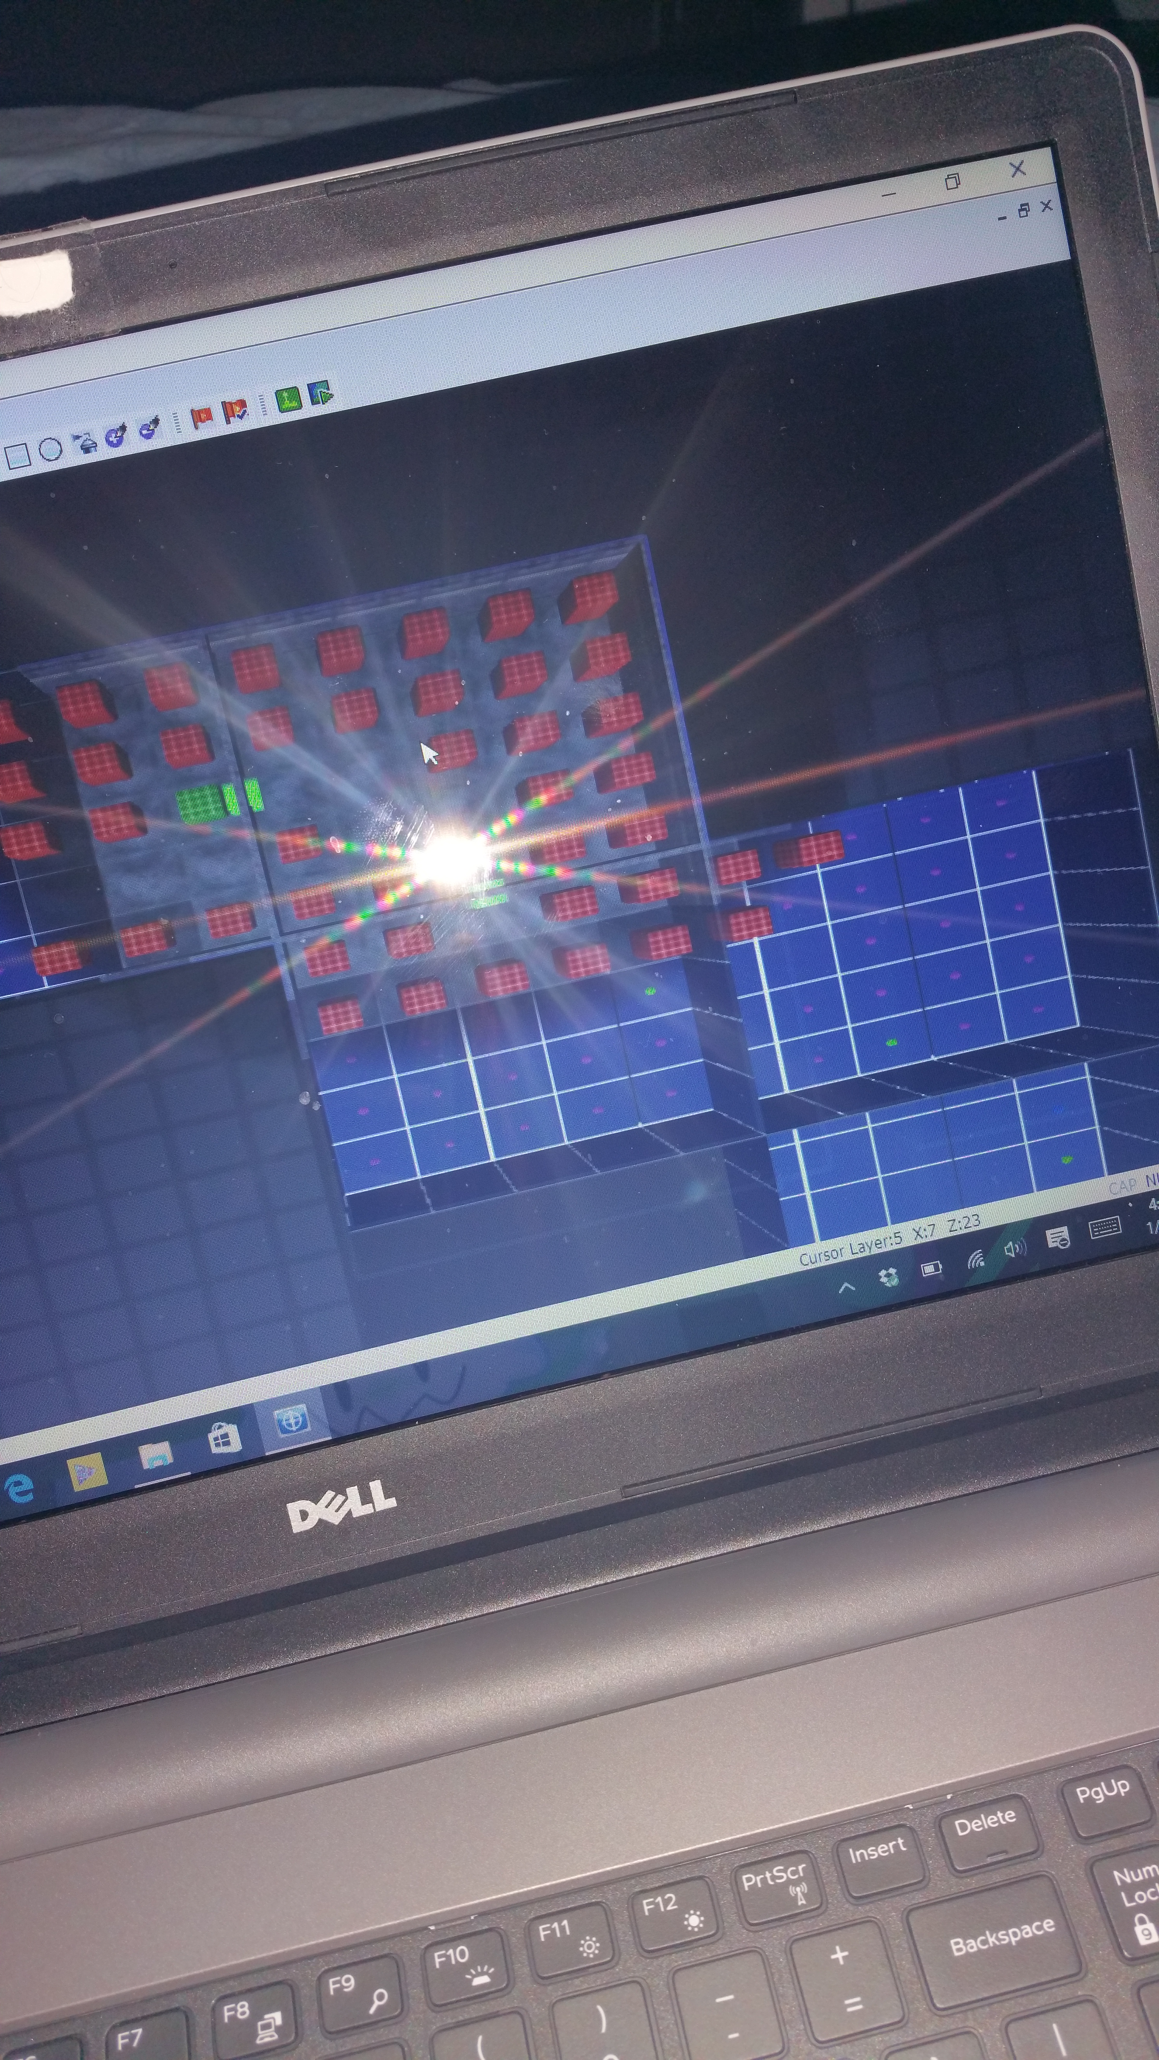
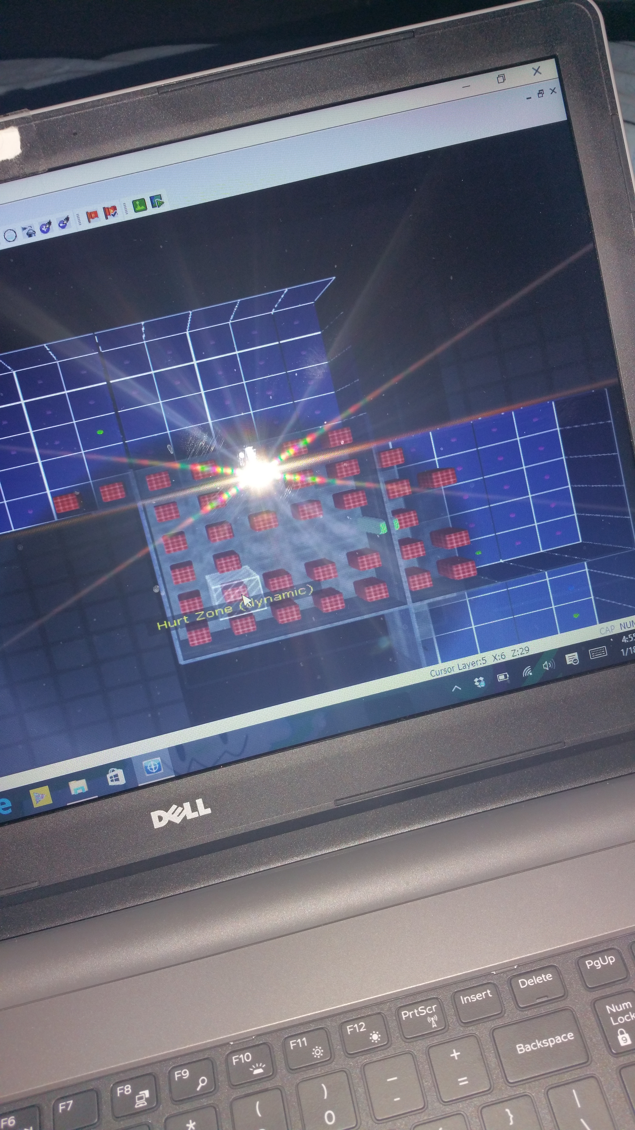
These two pictures show what you are dealing with.

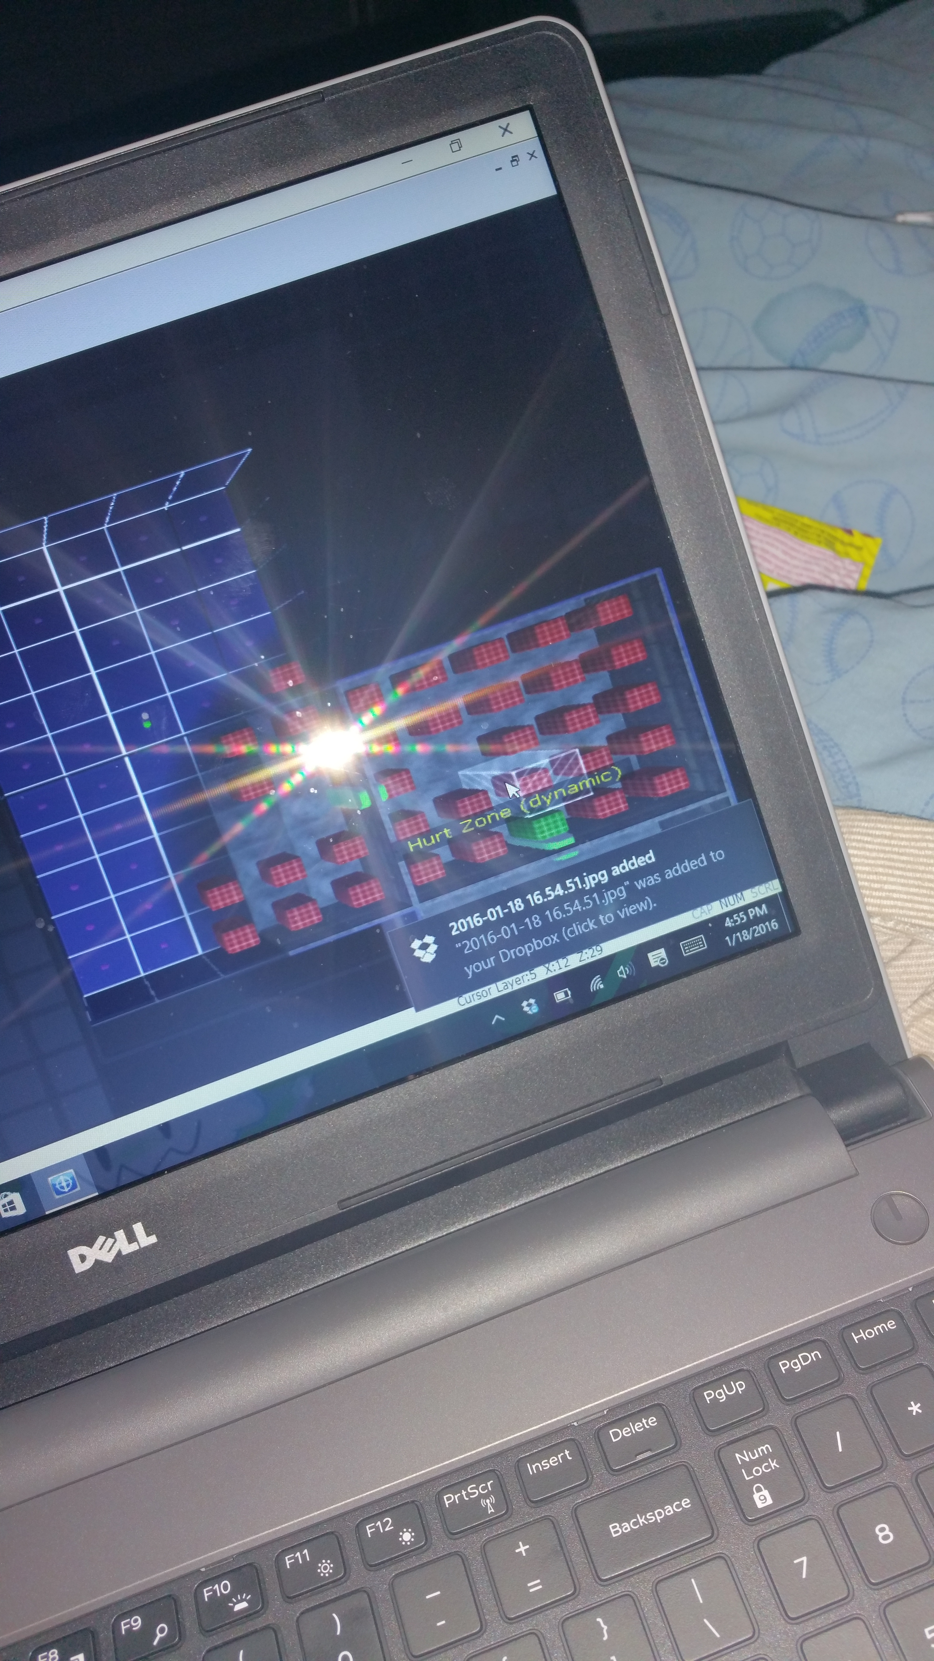
The next picture shows what THIS room is showing you.
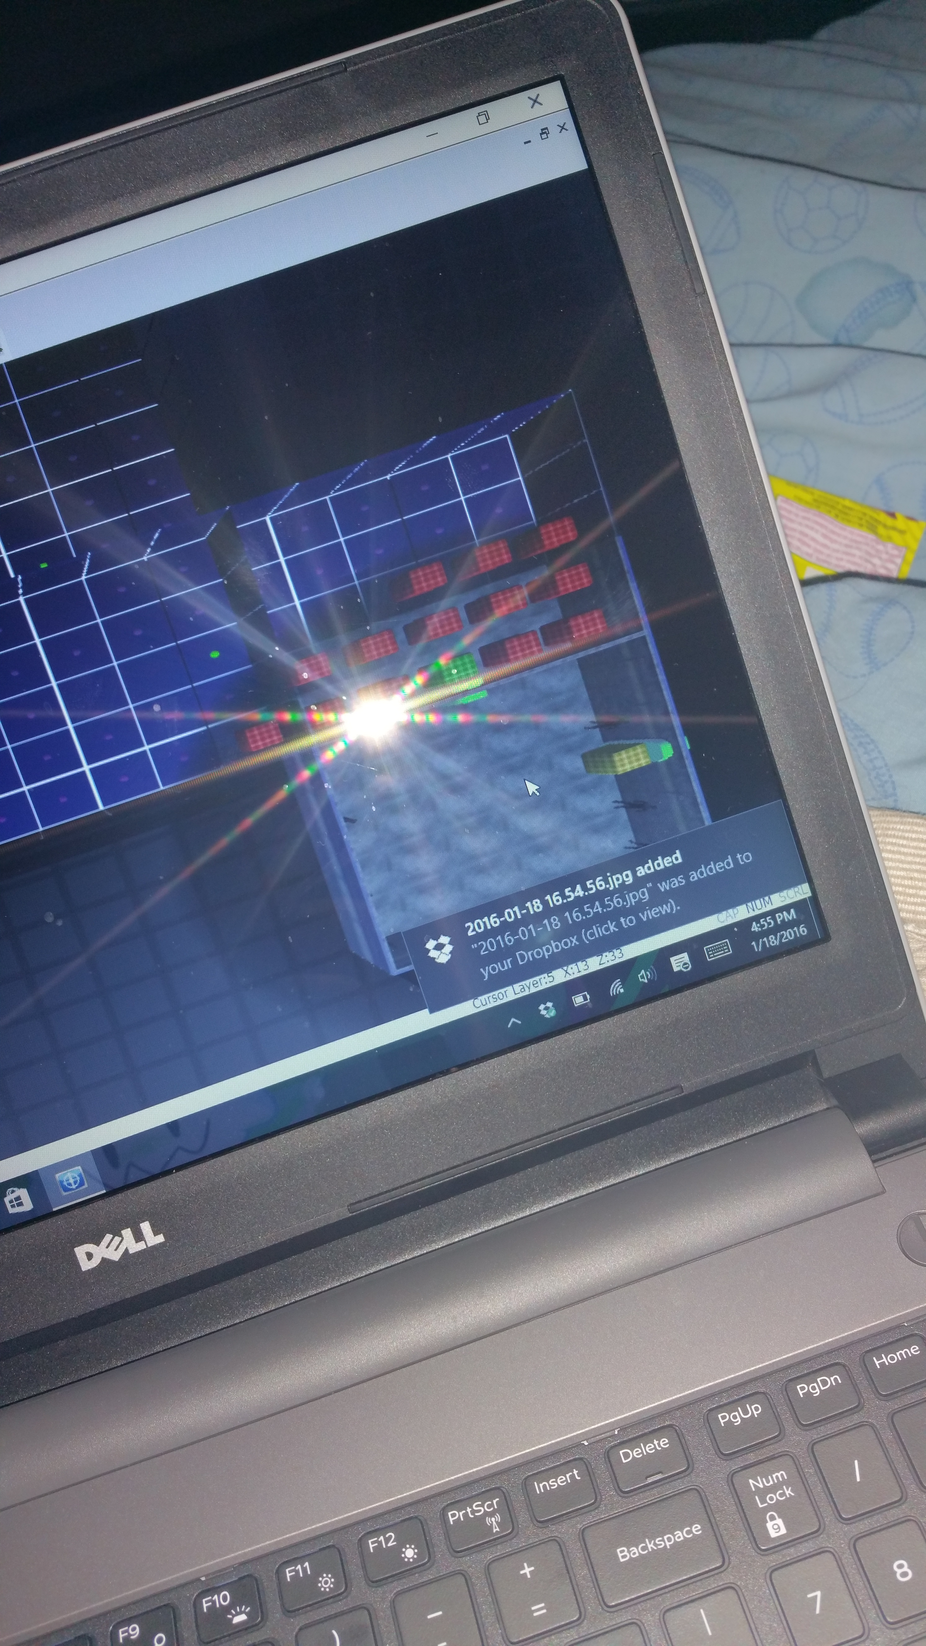
The last room however shows a bunch of people whom you may remember and look there is the exit out of this place.
I hope you enjoy this game I pretty much put thought into this one than the last one.

